Family of Distributions in Input Data Modeling

1:Exponential Distribution

* Models the time interval between consecutive events.
* Formula: f(x) = λe^(-λx), x ≥ 0
* Problem: A call center receives 3 calls per hour. Calculate the probability that the next call takes more than 15 minutes to arrive.
* Solution: Convert 15 min = 0.25 hour P(X > 0.25) = e^(-3×0.25) ≈ 0.4724%

2: Normal Distribution

* Symmetrical data around a central mean.
* Formula: f(x) = 1 / (σ√(2π)) * e^(-(x - μ)^2 / 2σ^2)
* Problem: IQ scores with mean 100 and σ 15. Find P(IQ < 115).
* Solution: Z = (115 - 100) / 15 = 1 → P(Z < 1) ≈ 0.8413%

3: Poisson Distribution

* Models the number of events in a fixed interval.
* Formula: P(X = k) = (λ^k * e^(-λ)) / k!
* Problem: Rate λ = 5 per hour, find P(exactly 3 events).
* Solution: P(3) = (125 * e^(-5)) / 6 ≈ 0.1404%

4: Binomial Distribution

* Number of successes in n independent trials.
* Formula: P(X = k) = C(n, k) * p^k * (1 - p)^(n - k)
* Problem: Flip 10 times, P(exactly 6 heads) with p = 0.5.
* Solution: P(X = 6) = C(10, 6) * (0.5)^6 * (0.5)^(4)

5: Triangular Distribution

* Data with known min, max, and mode.
* Formula: f(x) = (2(x - a)) / ((b - a)(c - a)) for a ≤ x < c
* Problem: Min 1, max 10, mode 4, x = 3.
* Solution: f(3) = (2(3 - 1)) / ((10 - 1)(4 - 1)) = 0.222

**6: Lognormal Distribution**

• Models a variable whose logarithm is normally distributed—used in modeling things like **time to repair a machine** or **stock prices**.



• **Problem**: The time (in hours) to repair a server follows a lognormal distribution with μ = 1 and σ = 0.5. What is the probability that the repair takes **less than 4 hours**?

• **Solution**:  
Convert to Z:

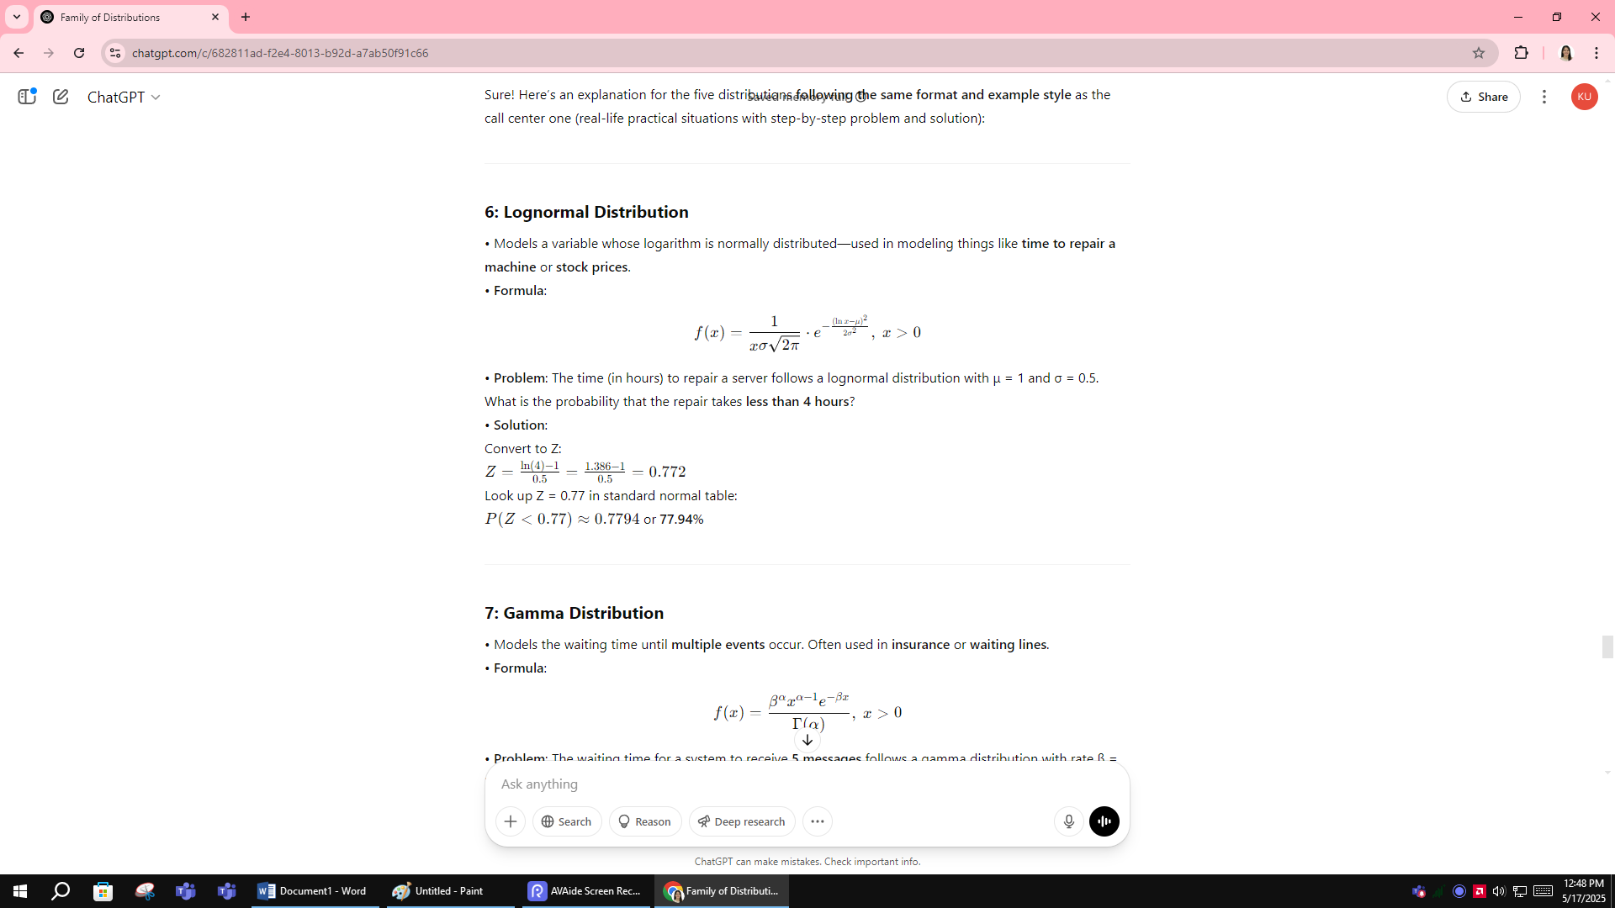

Look up Z = 0.77 in standard normal table:  
P(Z<0.77)≈0.7794 or **77.94%**

**7: Gamma Distribution**

• Models the waiting time until **multiple events** occur. Often used in **insurance** or **waiting lines**.  
• **Formula**:

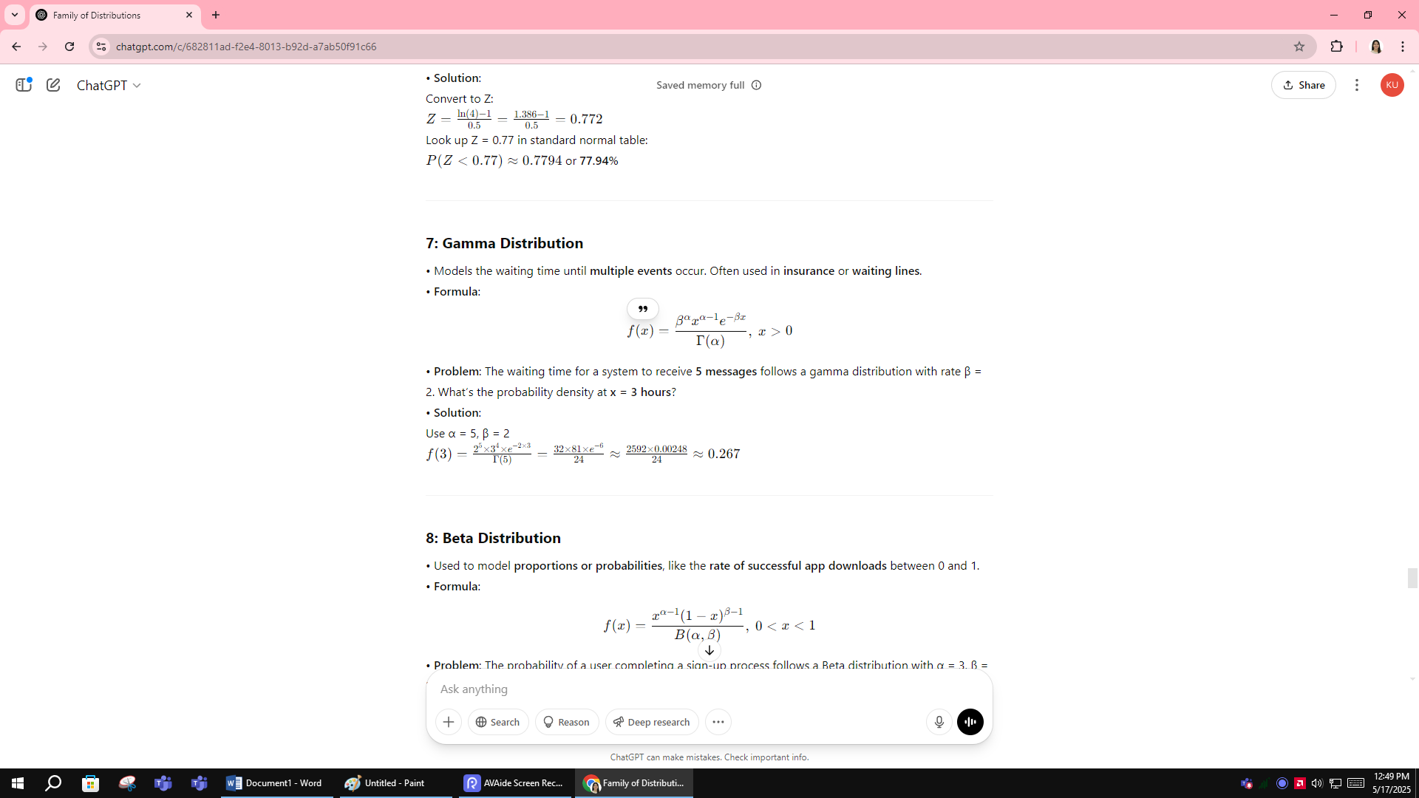

• **Problem**: The waiting time for a system to receive **5 messages** follows a gamma distribution with rate β = 2. What’s the probability density at **x = 3 hours**?  
• **Solution**: Use α = 5, β = 2

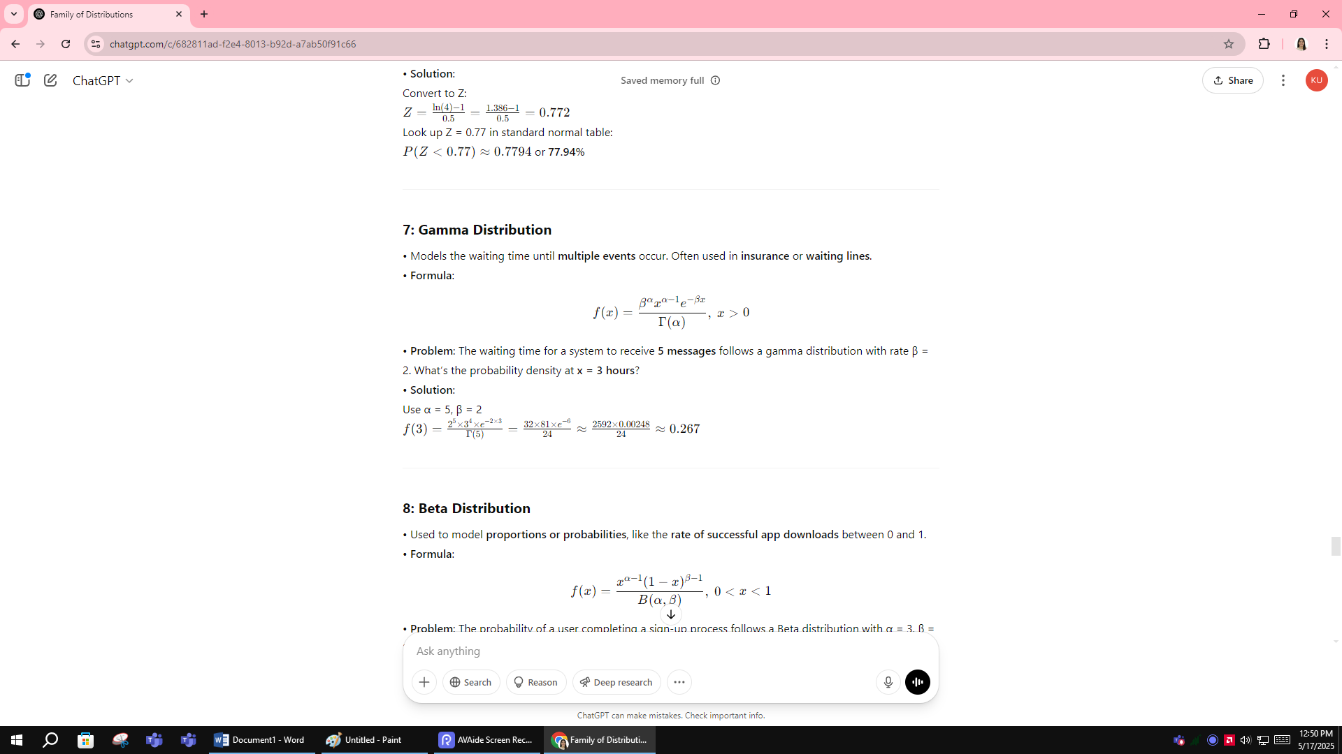

**8: Beta Distribution**

• Used to model **proportions or probabilities**, like the **rate of successful app downloads** between 0 and 1.  
• **Formula**:

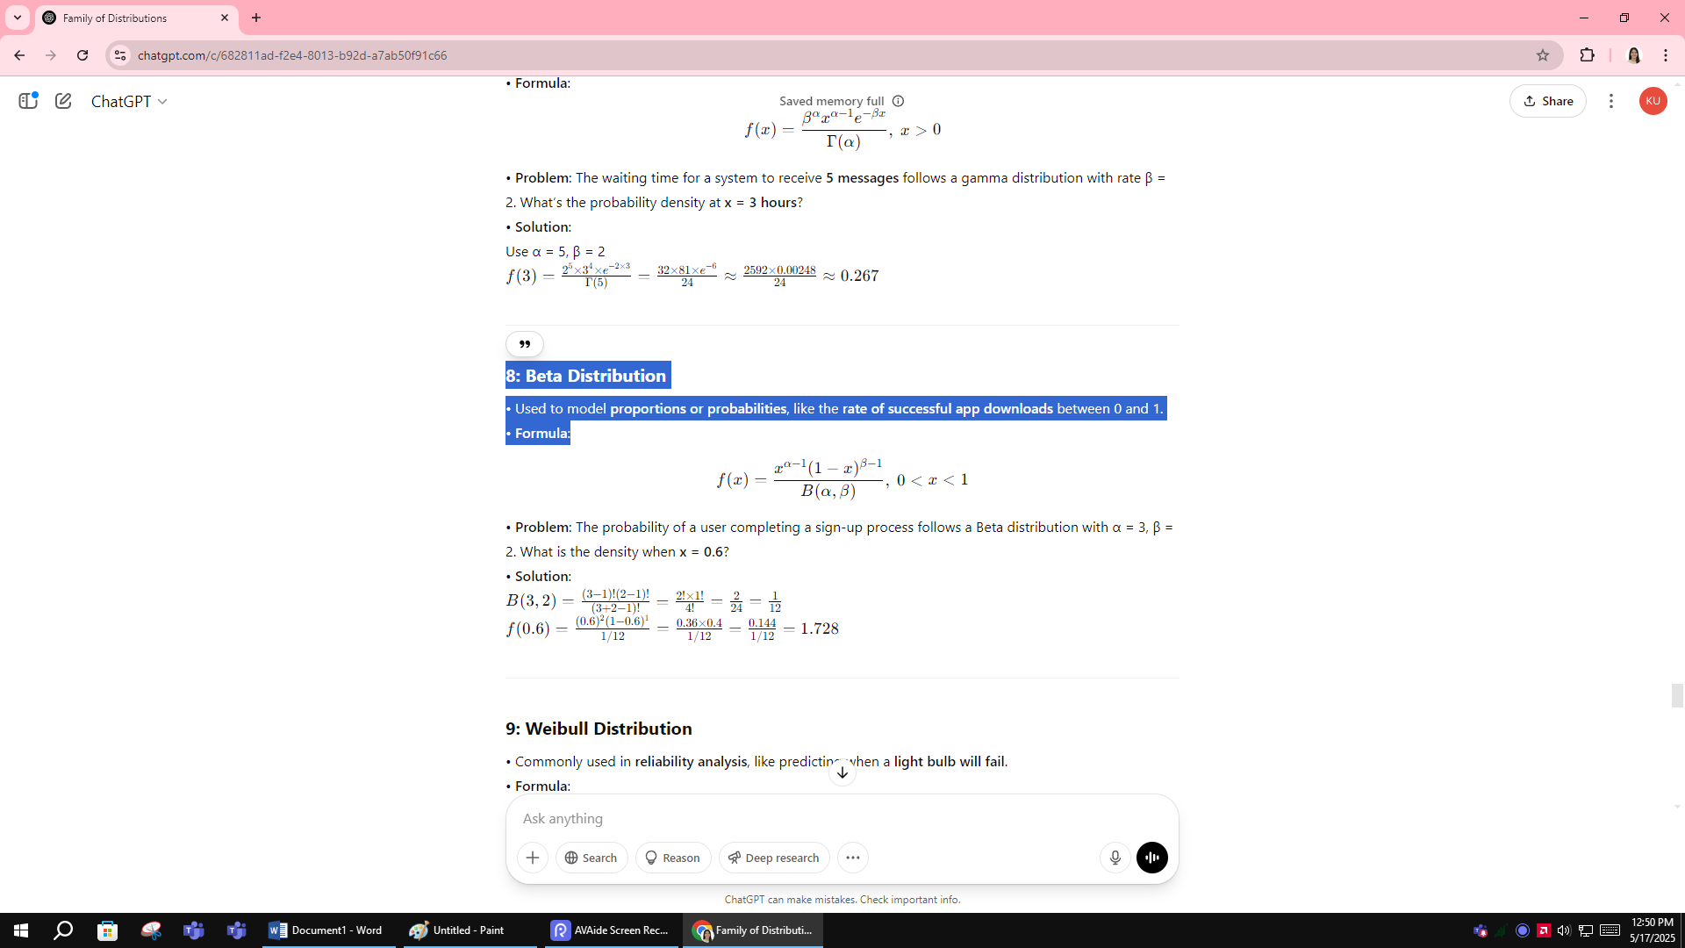

• **Problem**: The probability of a user completing a sign-up process follows a Beta distribution with α = 3, β = 2. What is the density when **x = 0.6**?

• **Solution**:

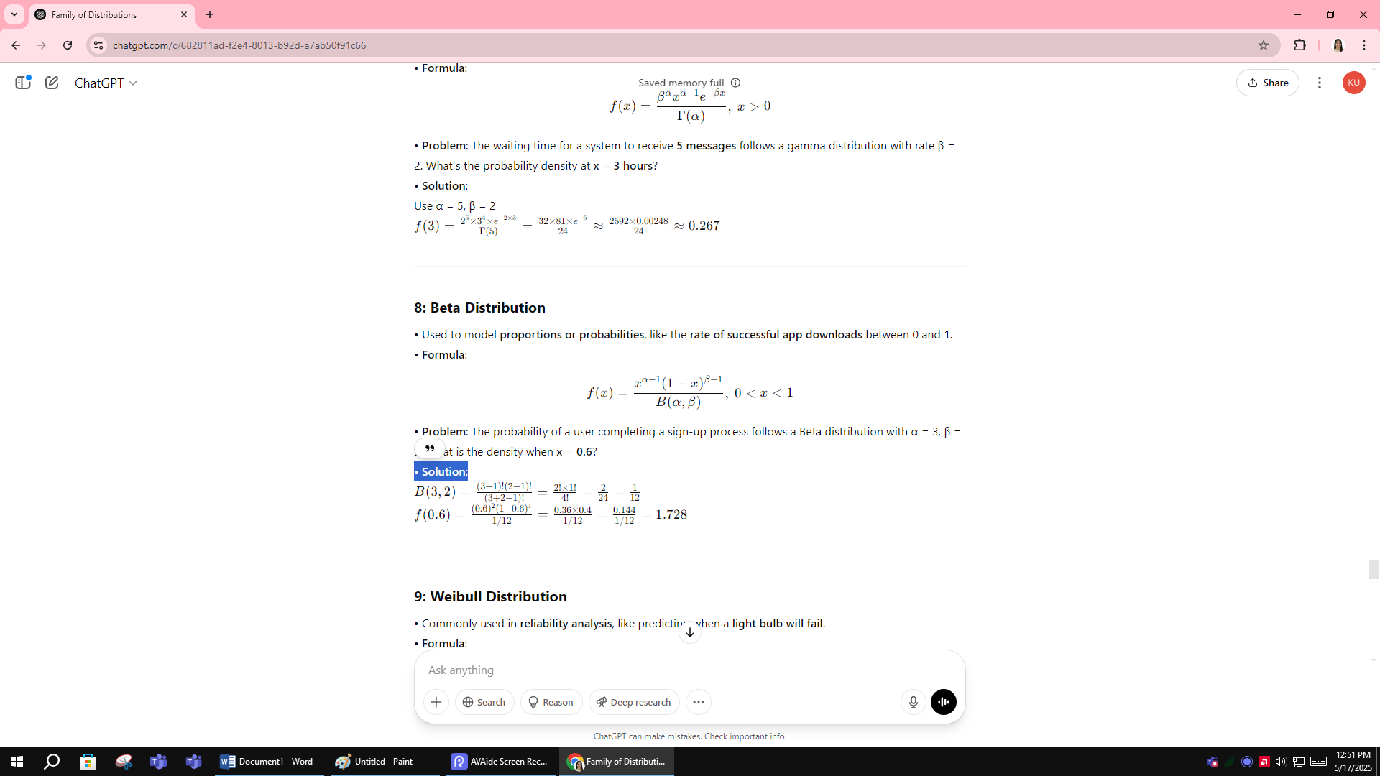

**9: Weibull Distribution**

• Commonly used in **reliability analysis**, like predicting when a **light bulb will fail**.  
• **Formula**:

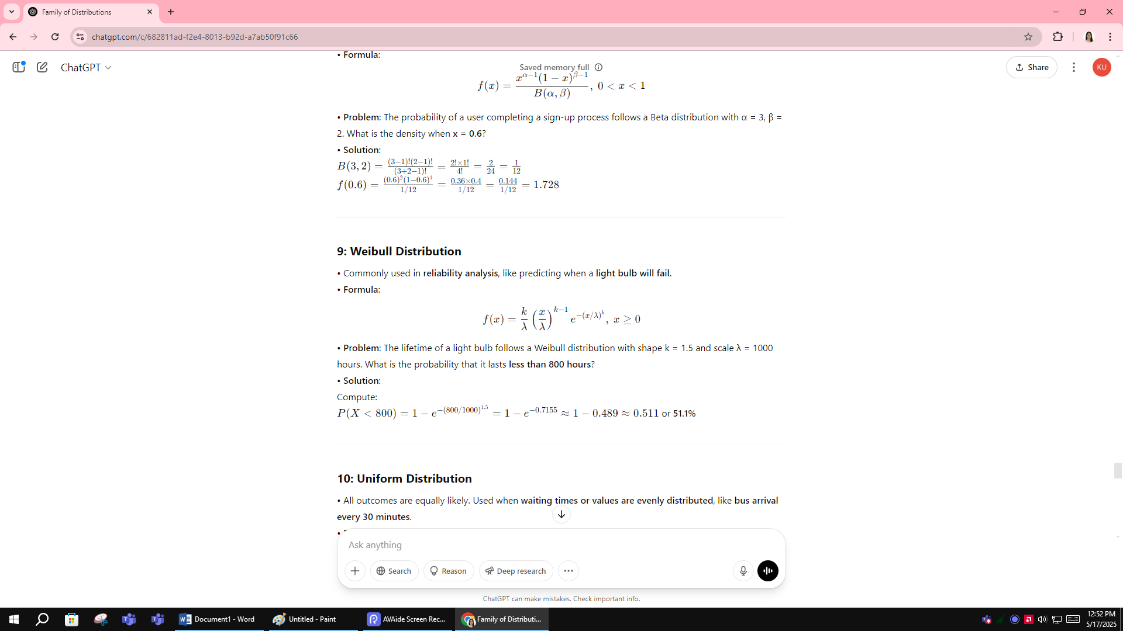

• **Problem**: The lifetime of a light bulb follows a Weibull distribution with shape k = 1.5 and scale λ = 1000 hours. What is the probability that it lasts **less than 800 hours**?  
• **Solution**:  
Compute:

P(X<800)=1−e−(800/1000)1.5=1−e−0.7155≈1−0.489≈0.511 or **51.1%**

**10: Uniform Distribution**

• All outcomes are equally likely. Used when **waiting times or values are evenly distributed**, like **bus arrival every 30 minutes**.  
• **Formula**:

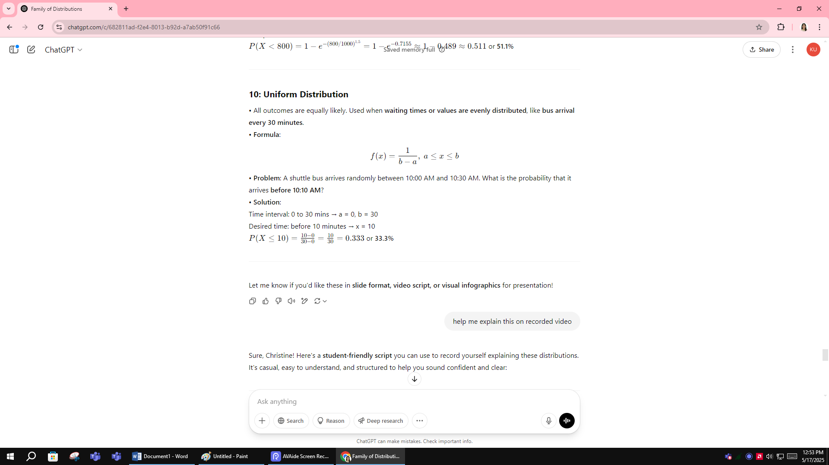

• **Problem**: A shuttle bus arrives randomly between 10:00 AM and 10:30 AM. What is the probability that it arrives **before 10:10 AM**?  
• **Solution**:  
Time interval: 0 to 30 mins → a = 0, b = 30  
Desired time: before 10 minutes → x = 10

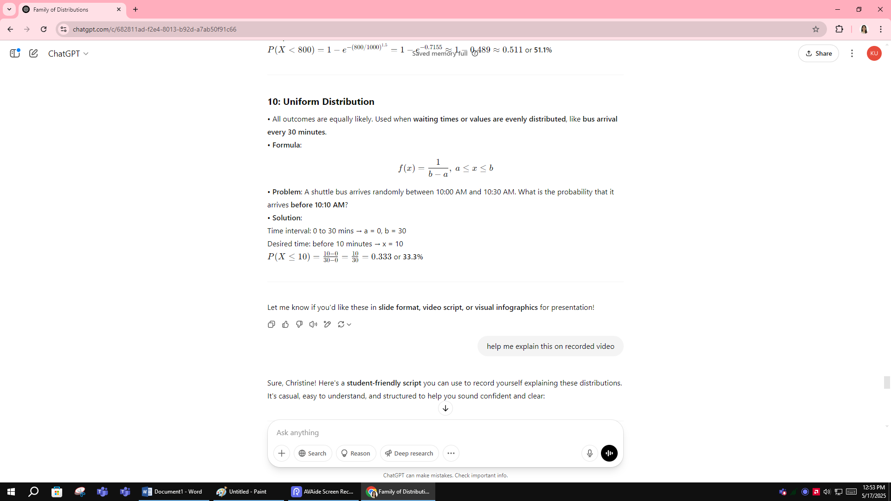

There’s ia 1 in 3 chance you will cath the bus before 10:10am